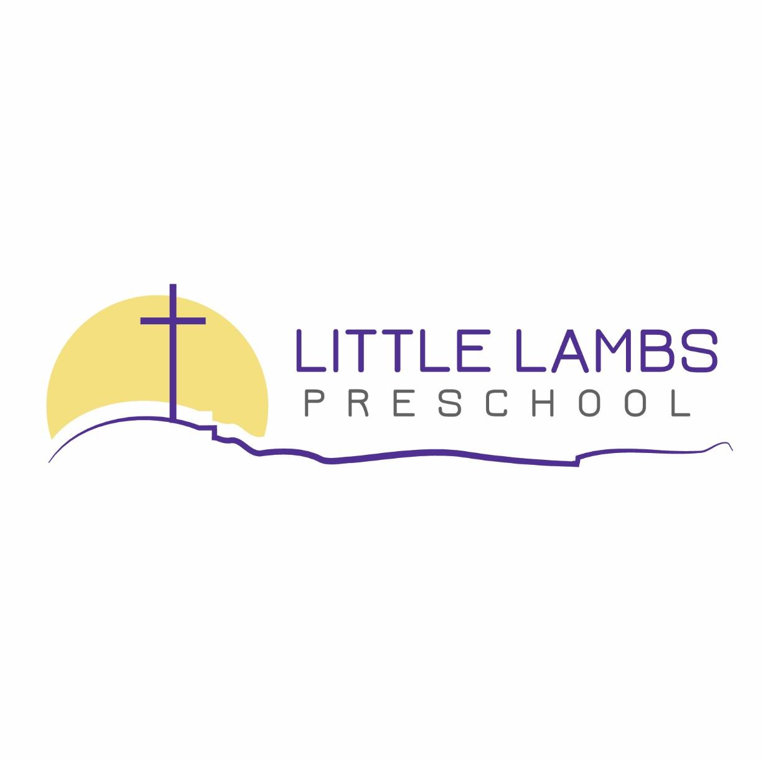

PARENT/GUARDIAN HANBDOOK
Revised December 16, 2025

St. Peter Evangelical Lutheran Church
4610 Hogan Drive
Fort Collins, CO 80525-3704
(970) 632-2097
www.stpeterlittlelambs.com

TABLE OF CONTENTS

Our Mission, Vision, and Philosophy p.3

Goals and Objectives p.3

Admission p.5

Enrollment and Registration Policies p.5

Tuition p.6

Class Sizes p.6

Schedule p.6

Wrap Around Care p.6

Drop-off/Pick-up p.7

Safe Departure Policy p.7

Custody Rights Policy.……..............………………………………………………………………………p.8

Absences p.8

Discipline/Guidance p.8

Termination of Enrollment p.9

School Calendar p.10

Emergencies p.10

Meals and Snacks p.10

Rest Time p.10

Dress and Items from Home p.11

Health/Safety p.11

Weather p.12

Curriculum p.12

Communication p.13

Family Ministry p.13

Babysitting & Mandatory Reporting…………………………………………………………………….. p.14

Filing a Complaint…. p.14

Ways Parents Can Help & Contact Info p.14
Our Mission: Little Lambs Preschool is a ministry of St Peter Lutheran Church. It is the mission of Little Lambs Preschool to provide young children with an education founded on the truths of God’s saving Word and the love of Jesus, their Savior, that supports spiritual, intellectual, physical, social, and emotional development, and to bring hope to families as we partner with them in the training up of their children.

Our Vision: As servants of Christ and with God's help, St. Peter Lutheran Church and the staff of Little Lambs Preschool will serve families of the congregation and community with a quality program of Christian education for both children and parents in a safe, nurturing, and well-equipped environment. All programs will rely on parental support both financially and through personal involvement.

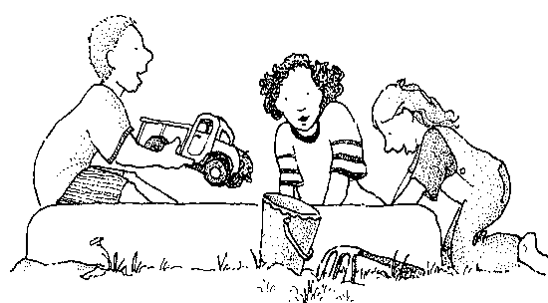
Our Philosophy: Christian preschool education shares God’s love and mercy in Christ with each child and supports Christian parenthood and home life. It prepares children for kindergarten and aids in early detection of academic, social, and emotional needs. Children learn at different rates, depending on their own God-given capabilities and desires. Little Lambs Preschool is here to patiently serve those seeking a contemporary Christian education for their children. With the Lord’s help, we will serve you to the best of our abilities by empowering staff, children, and parents, providing a meaningful learning experience, and developing a positive self-concept for members of God’s family.
“These commandments that I give you today are to be upon your hearts. Impress them on your children. Talk about them when you sit at home and when you walk along the road, when you lie down and when you get up.”
— Deuteronomy 6:7 & 8

Goals and Objectives
Although parents have been given the primary responsibility for the training of their children, our church wants to assist parents in the training of their children. Therefore, it shall be the objective of Little Lambs Preschool

To help each child:
- grow spiritually in their relationship to Jesus by teaching them the truths
about God’s wonderful plan of salvation for all people.
- grow in Christian management of their time, talents and treasures.
- learn to express their faith in their relationship with others, especially peers.
- develop academically to their potential through new learning experiences via supervised hands-on discovery.
- develop emotionally as they grow in self-confidence, concern and respect for others, cooperation in work and play, and a spirit of sharing.
- develop physical dexterity, strength and coordination to their fullest potential.
- develop socially and help them acclimate to the school environment in preparation for kindergarten.

To communicate to you as parents:
- our love for your children.
- our desire to help your child form a strong academic foundation.
- our curriculum and ideas for home use through weekly emails, monthly calendars, and parent/teacher conferences.
- our joy that you have enrolled your child.
- our willingness to be of help to you whenever it is possible.
- our love for our Savior.

To encourage you as parents:
- to visit our church.
- to visit Little Lambs whenever you desire.
- to read God’s Word.
- to be active Christian role models for your children.
- to be active participants in your child’s education at home and at school.

Goals for Each Child
Spiritual Goals:
- to know God is real.
- to understand that God loves each one of us.
- to know the Bible is God’s Word and is true.
- to become familiar with and understand the Bible stories.
- to know that God is the creator of all things.
- to know that Jesus is God’s own Son.
- to learn to pray.
- to know God answers prayer.
- to know that God is in control and has purpose for everything.
- to know the true significance of Christmas and Easter.

Emotional Goals:
- to develop positive self-esteem.
- to develop responsibility for self and possessions.
- to begin growing in self-discipline, decision making and problem solving.
- to be able to make choices, plan and carry out their own ideas.
- to express emotions in a controllable fashion.
- to know true happiness as a member of God’s family.

Social Goals:
- to be able to take turns, share, compromise, and respect others.
- to be able to interact (communicate) with adults and peers in an acceptable manner.
- to be able to join in both group and individual activities.
- to be able to obey rules and directions and understand their necessity.
- to be able to recognize how one’s behavior affects others.

Academic Goals:
- to develop a lifelong love of learning.
- to construct knowledge through supported hands-on experiences.
- to develop reading readiness skills of visual and auditory discrimination, memory, and sequence.
- to use appropriate oral and written language.
- to have experience with color, shape, numerals, and the alphabet.
- to gain pre-math experiences with patterns, matching, classifying, comparing, and sequencing (ordering).
- to develop an appreciation for music and art through many creative activities.
- to gain a greater understanding of God’s wonderful creation (science awareness).
- to gain an understanding of self, family, and community.

Physical Goals:
- to develop dexterity, coordination, and strength to their fullest potential.
- to develop good health and grooming habits.
- to develop good nutrition habits.

Admission:
Little Lambs Preschool does not discriminate based on a person's sexual orientation, religion, disability, race, creed, color, sex, age, national origin or ancestry.

All children three to five years of age will be admitted, meeting the following requirements:

- Child must be 3 years old by September 15th. This means a child must be 3 by September 15th to start at any time throughout the current school year.
- Child is fully potty trained* unless there is a disability that prohibits this. A signed note from the child’s physician must be turned in for proof of disability.
- Classes are filled on a first come, “first serve” basis. Your child’s name may be put on a waiting list to fill vacancies as they occur.
- A non-refundable, one-time/school year fee of $125 is due at the time of registration for each school year.
- Enrollment paperwork must be completed and submitted prior to the child’s first day of attendance (see above).

We will accommodate children with special needs on a case-by-case basis after consultation with the child’s parent(s).

*A fully potty-trained child is able do the following:

- Tell the adult he/she has to use the bathroom.
- Pull down underwear and pants and get them back up without assistance.
- Get onto/off the toilet independently.
- Wipe him/herself after using the toilet.
- Wash and dry hands thoroughly.

Enrollment and Registration Policies:
You will receive an enrollment packet for each child you are planning to send to Little Lambs Preschool. The entire enrollment packet as well as a signed health statement from your child’s physician (blank form included in enrollment folder) must be turned in to the director before enrollment is confirmed.
These forms and the $125 nonrefundable registration fee will secure a spot for your child.

Registration Details:
Registration is open to all students beginning February 1st. Returning families can register two weeks prior to that date. Priority is given to applicants desiring 5 full days first, followed by 2 & 3 full days, and finally half day applicants. Half day space is limited and not guaranteed.

If the school is full, your child’s name will be placed on a waiting list, and you will be notified when an opening is available. The registration fee is not required if your child is put on the list.

Tuition:
Tuition and the $4.00/month technology fee is posted in SMARTCARE on the 1st of the month. You have until the 10th of the month to pay. It is the parent/guardian’s responsibility to know how much is due (please see itemized fee schedule below). After the 10th of the month, unpaid tuition will be considered late and an additional fee of $25 will be added to your balance. Your child may be withdrawn if tuition is not received by the end of the month.

Tuition will be paid through SMARTCARE using your credit card or bank routing information. Please note: if you use a credit or debit card a hefty processing fee will be charged to your account. Using your bank routing information will not cause an additional fee.

Please note that Little Lambs does not prorate or adjust tuition rates for days that school is not in session. For example: Thanksgiving, Christmas, and Spring break.

UPK: Families enrolling in the Universal Preschool Program (UPK), will be responsible for the one-time Little Lambs registration fee. Families will also be responsible for any tuition not covered by the UPK program and the fees due until Little Lambs receives the funds from the state.

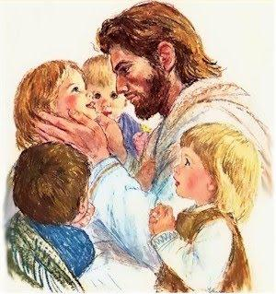
Half Day Tuition Prices (Monthly)
3 Days | $360.00
5 Days | $600.00

Full Day Tuition Prices (Monthly)
2 Days | $400.00
3 Days | $600.00
5 Days | $900.00

Classroom size:
Little Lambs Preschool uses a mixed-age classroom approach to learning. Our mixed-age classrooms (ages 3-5) will always have a maximum teacher-student ratio of 1:10, never to exceed 20 students per room.

Class Schedule: Little Lambs Preschool operates Monday to Friday from 7:00a.m.- 4:30p.m. Classroom hours are 8:30 a.m. – 3:30 p.m. Wrap around care before and after school may be offered if there is enough interest (min of 3 students). Daily schedules can be found in the enrollment folder.

Wrap Around Care Hours:
(Provided when there are sufficient numbers)
Little Lambs Preschool may offer before and after school care to our preschool families if there is enough enrollment** This care would be available from 7am-8am and again from 3:30pm-4:30pm with a $10 charge for each use. You will be charged for the full hours regardless of the minutes used. To ensure the program is efficiently utilized there will be a $250 deposit to use this program. This $250 fee will serve as a down-payment for the program; the amount will cover the $10 daily use fees until exhausted (i.e. there will be no added charges for the first 25 uses). There will be no refunds on funds that are not used by the end of the year. A bill for wrap around care will be posted in SmartCare by the 1st of the month with a total for the previous month. This amount will be due with tuition by the 10th of the month.
** Little Lambs will offer before and/or after school care if 3 or more students are enrolled in the program. If there are fewer than 3 students enrolled, the program will not be available for the semester and any paid wrap-around deposit fees will be completely refunded.

Drop-Off/Pick-Up:
The drop off time for class is between 8:00 a.m. and 8:30 a.m. Morning session pick-up is at 11:30 a.m. Full day pick-up time is 3:30 p.m. Each child must be accompanied by an adult into the classroom and signed in and out every school day. Pickup authorization must be in writing; a phone call will not be accepted. Please be sure the school is always provided with an up-to-date list of people authorized to pick up your child. Little Lambs Preschool may ask for a photo ID before the child is released to anyone on his/her authorized list.

If you bring your child before 8:00 a.m. you will be charged $10.00 for morning wrap around care. If your child is picked up after 11:45 a.m. or 3:45 p.m. you will be charged $10.00 for wrap around care.

If your child is not picked up within 15 minutes after dismissal, the parents will be contacted. If the child is not picked up within a half hour after dismissal time and authorized pickups cannot be reached, the preschool will contact the Fort Collins Police Department and/or the Larimer County Social Services.

Safe Departure Policy:
If we are concerned for the safety or well-being of your child, should we release that child to you, we will inform you of our concern and call another person on Authorized List to pick up the child.
If we are concerned for your child’s safety when a person on your Authorized List picks up your child, we will phone you immediately and/or call another person on your Authorized List to pick up your child.
Before we release a child to a person whose behavior is potentially unsafe, we may take the following steps:
- Remove the child from the immediate environment; comfort and reassure the child of his/her safety.
- Share our concern with the person attempting to pick up.
- Remind the person of our Safe-Departure Policy.
- Enlist the help of an appropriate family member, either in person or by phone.
- Call another person on the Authorized List to step in and pick up the child.
- Call the police (when necessary)
- Report potential abuse or neglect to the appropriate authorities.
Policies Regarding Authorized Lists:
Persons on the Authorized List must be at least 18 years of age and able to document their age and identity.
Only those on the Authorized List will be allowed to pick up the child. Anyone NOT listed on the Authorized List who attempts to pick up will be denied access to the child.
Any changes to the Authorized List must be made in writing by the enrolling parent/guardian.
All attempts will be made in good faith to contact you and the others on your Authorized List, but if no one can be reached at the time the program closes, the Department of Social Services along with the police department will be notified.
Custody Rights Policy:
Under the laws of the state of Colorado, both parents may have the right to pick up their child unless a court document restricts that right. The enrolling parent who chooses not to include the other parent's name on the Authorized List for pickup must file an official court document such as the following:
- Current restraining order
- Sole-custody decree
- Divorce decree stating sole custody
- Judgment of adoption
- Foster parent documentation
Absent this documentation, the program may release the child to either parent, provided that parent documents biological or adoptive parenthood of that child. The parent must provide the program with updated legal documents when any changes occur.

*For separated/divorced parents who share custody of a child and will be alternating pick-ups, we ask that you fill out our Shared Custody Agreement Form. Please speak with the director if you need to fill out this form.

Absences:
There will be no refund or reduction in tuition for absences. If your child is ill, please call Little Lambs Preschool as soon as you know you will be keeping your child at home. If your child will be arriving late or leaving early for a necessary appointment, please inform the staff in advance. If your child will be absent for a planned vacation, please notify staff as far in advance as possible.

“Train a child in the way he should go, and when he is old he will not turn from it.”
— Proverbs 22:6

Discipline/Guidance:
Little Lambs Preschool will provide individualized social and emotional intervention support for children who need them. This includes methods for understanding child behavior; and developing, adopting, and implementing a team-based positive support plan with the intent to reduce challenging behavior and prevent dismissals.

Child guidance is implemented in a way that promotes the development of self-esteem and problem-solving skills. Little Lambs develops a daily schedule, classroom routines, and consistent expectations to create an environment in which the child feels safe and secure.

Aggressive behavior is responded to through positive redirection and education. Children are taught the skills to handle frustration and anger in ways which do not hurt their friends or disrupt the classroom. In the case of persistent challenging behavior, teachers will problem-solve with the child’s parents and the director. This will be done in an approach that displays Christian love and respect.

Positive Discipline
Discipline is derived from the word disciple, meaning “to teach.” Therefore, at Little Lambs, we do not think of discipline as punishment, but rather as a means of teaching. One objective of Little Lambs is to assist children in improving self-regulation and self-control. The following are some ways in which we will help children gain better self-control:
- Prevention -a well-planned schedule with little wait time.
-changing activities when children become restless.
- Redirection -focus the child’s attention on something else besides what is
frustrating him/her.
- Be Positive -making positive requests (“please walk” vs. “don’t run”)
-pointing out the achievements of each child.
-using polite manners with the children.
- Be Consistent -teachers work together to set and enforce room rules.
-teachers and families work together to create positive discipline plans.
- Dignity -misbehaviors will be handled privately.
-a child’s misbehavior will not be announced to the class.
-teachers will treat each child as a unique gift from God

If dismissal is required, families will be guided and referred to the local Colorado Preschool Program Coordinator or Child Find to gain access to tools that set your child up for success.

Little Lambs Preschool will not use humiliation, fear, or any kind of abuse to respond to children who misbehave.

Termination of Enrollment:
By Parent/Guardian
To withdraw your child from Little Lambs, a two-week written notice must be given to the director, and there must be no outstanding fees owed. Tuition fees are non-refundable through the last day of the notice and all outstanding fees must be paid.

By Little Lambs
While it is our goal to be able to educate each child and provide quality care for each family, Little Lambs Preschool reserves the right to terminate a child’s enrollment at any time for any of – but not limited to – the following reasons:
- The child displays a consistent pattern of aggressive and/or destructive behavior that endangers oneself or others.
- The child displays a consistent pattern of bathroom accidents that suggests that the child is not toilet trained.
- Both the staff and the parents concur that the current enrollment of the child is not meeting the needs of the child; the required notice may be waived.
- The parents are in violation of established policies and practices of Little Lambs including code of conduct, non-payment of fees, failure to submit required information and forms, or not observing the rules and practices of the center.

School Calendar:
A copy of our school calendar will be provided in the enrollment packets. The calendar mostly follows PSD scheduling and is subject to change at any time.

Emergencies:
Parents must provide the preschool with up-to-date contact phone numbers, for both home and business.

Fire drills will be conducted regularly as required by the state. Each staff member will walk the children to the designated area and wait for instruction from the director/fire department when it is safe to return to the classroom. Staff will bring their classroom backpack that includes a first aid kit, binder with student info and any prescribed medications. In case of an actual emergency, parents will be notified as soon as possible.

In the case of a natural disaster, the following procedures will be followed:

- Preschool staff will listen to news/weather reports for information and instruction.
- Staff will keep children calm and comfortable while parents are being contacted.
- In the event of a tornado, the designated safe area is the bathroom.

If the preschool director and/or teacher believe any child (or the children) is at risk of potential harm, whether by natural disaster or other perceived threat to human safety, and remaining in the building is the safest option, staff may lock all exits accessing the school. If a decision is made to implement a lock down, staff will then do a head count, retrieve the emergency phone numbers, and take the children to a designated safe area. These are precautions for rare, unpredictable, and isolated events.

For more detailed information, please see Little Lambs Preschool’s Emergency Action Plan located in the Director’s office.


Meals and Snacks:
Little Lambs does not provide snacks or lunch. Half-day students will bring one snack from home. Full-day students will bring two snacks and one ready-to-eat lunch (this includes utensils and a beverage). Snacks and lunches will be stored in refrigerators until snack/mealtime. We do not use microwaves to heat up food, so please do not send anything that needs to be prepared using a microwave.

Nutritious snacks and lunches are important in helping children grow. When packing food for your child, please keep in mind that the USDA recommends that a snack includes 2 of the 5 major food components, and a meal includes all 5 components. The 5 components are meat/meat alternate, dairy, vegetables, fruit, and grains.

Rest Time:
According to Colorado state regulations, all children in the full day program will have a rest time each afternoon. Little Lambs will provide cots for rest time. If the child cannot fall asleep, a quiet area with activities will be available so the children who are asleep will not be disturbed. All families enrolled in the full day program are required to send a fitted sheet for the mat. Blankets and small pillows are welcome as well. All sleeping items must be taken home once per week to be washed.

Dress and Items from Home:
Colorado has a wide range of weather; therefore, we ask that you dress your child appropriately for the day’s weather. We will be going outside daily as the weather allows.

Dress for PLAY! Keep in mind that while your child is at Little Lambs we will be doing creative, messy learning activities. Please refrain from sending your child in “dressy” clothes which might limit his/her ability to learn and play. Dress your child in comfortable play clothing and shoes that allow for easy movement. Flip-flops – although easy – make running difficult and frustrating for a child. Please send your child in closed-toe shoes with backs.

Your child will need at least one complete set of extra clothing (shirt, pants/shorts, underwear, socks, etc.) to use when accidents occur. Please update these as your child grows and as the weather changes.

Please keep all other toys or personal items at home. Any standard safety equipment (i.e., helmets) or items for special needs may be sent to school. Please discuss these items with preschool staff.

Health and Safety Issues:
*When necessary, any state and local public health mandates/guidance will supersede the policies listed in this section. You will be informed of any such changes.
Little Lambs is committed to providing a safe and healthy environment for children and staff. If a child becomes ill while at school, we will make sure that he/she is comfortable and away from the rest of the children. We do not have the facilities to care for sick children, so it is important that he/she be picked up as soon as possible. Every effort will be made to contact the parents/guardians; however after 30 minutes of unsuccessful attempts, we will contact the emergency contacts listed on the registration forms. The sick child may remain at the center for 1 hour after the parent or guardian has been notified.

Your child will be sent home if any of the following symptoms are observed:
- A fever over 100 degrees
- A skin rash not identified by a practicing physician
- Infected area of skin (impetigo, ringworm)
- Diarrhea
- Unusual or unexplained loss of appetite, fatigue, irritability, or headache
- Vomiting
- Evidence of head lice
- Persistent coughing
- Discharge or drainage from eyes, nose, ears, or open sores
- Conjunctivitis (pink eye)
- Sore throat
- Pain that interferes with normal activities
- Chills or achiness

A child must be symptom-free for a minimum of 24 hours without any symptom-controlling medication before returning to school. If you are unsure whether or not your child may attend, please contact the director before bringing him/her to Little Lambs.

PLEASE CALL/TEXT IF YOUR CHILD WILL NOT BE ATTENDING SCHOOL.

In the event your child has been exposed to a communicable disease, you will be notified by a note sent home. A child may not be readmitted to school until a release is obtained from their physician for the following diseased:
- Whooping Cough
- Diphtheria
- Meningitis
- Typhoid fever
- Tuberculosis
- Any other unusual disease

If your child requires prescription medications during school hours, a medicine administration form must be completed, and the prescription medicines must be in original containers for staff to administer. Over-the-counter medicines must also be in original containers and must be accompanied by a signed note from a doctor. Do not send medicine in lunch boxes or on your child.

If your child should be injured, the staff will administer first aid. You will be notified by phone if your child’s injury is significant. An accident report form will be completed for all accidents/injuries.

Weather:

Because the weather in Colorado changes rapidly, please send your child with appropriate outerwear, including protective shoes and/or boots as we plan to go outside whenever possible. In the event of inclement or excessively hot weather, staff will use their discretion and may choose to keep the children inside. Staff will apply sunscreen within half hour of outdoor play. A sunscreen permission form is included in the enrollment packet. Look for weather-related school closure announcements on Little Lambs Preschool’s Facebook page, communication apps, and in emails. When PSD closes for inclement weather, we do, too. If school is closed, there will not be future make up sessions.

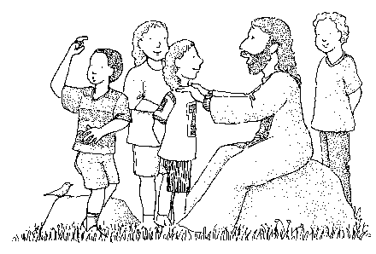
Curriculum:
Bible Time - the children will learn about God and His Word through Bible stories, Bible verses and Christian songs. The children will learn of God’s great love for us through Jesus.
Large Group Time - the children will develop listening, emergent, literacy, and comprehension skills through stories and activities. During large group time the children also have experiences with rhythm and movement, nursery rhymes, finger plays, singing games/songs, and problem solving.
Small Group Time – the children will get to work with one of the teachers in a smaller group setting to further explore new concepts. The teacher will use a variety of planned lessons to guide/teach hands-on activities toward fine motor development, literacy, pre-math concepts, and other educational skills. Small group time also allows the teacher to develop a closer relationship with and deeper understanding of each unique child.
Work Time- Each day we will work on our academic goals to have experience with one or some of the following: the alphabet, numerals, colors, shapes, and math concepts. We will also be incorporating Zoo-Phonics curriculum to help learn these important skills.
Free Play – Each day, the children will have time for free play. The classroom is divided into many different interest centers to provide the children with many opportunities to learn through active involvement and social interaction.
Recess- on supervised play areas (outdoor playground) and/or organized activities daily when the weather is favorable. We will use inclement weather opportunities to learn exercises, practice balance, hopping, skipping, jumping and other movement fun!

“Let the little children come to me, and do not hinder them, for the kingdom of God belongs to such as these.”
— Mark 10:14

Daily Routines/Accountability of Children Policy:
The daily schedule is included in your enrollment packet and will be posted on the parent board inside the preschool, as will any anticipated changes. All classrooms are equipped with a “go” backpack which includes a daily roster and emergency contact info for each child. This information is used to identify where children are at all times of the day.

Parent-Teacher Conferences and Communication:
Optional parent-teacher conferences will be held 1-2 times a year or by special request. These brief meetings allow staff to give detailed observations on a child’s social, emotional, and physical development. Appointments will be made for the formal conferences. If at any time a parent has a question or a concern, please feel free to speak with or email your child’s teacher or the Director.

Family Ministry:
We recognize that God gives the responsibility of raising children who know and love Him to parents. It is our goal to assist families as they grow together in their love for our Lord and for each other. During the year, we will offer Bible studies, and other opportunities for our preschool parents to learn more about our God and His Word. We strongly encourage you to take advantage of these opportunities.

“Fathers, do not exasperate your children; instead, bring them up in the training and instruction of the Lord.”
— Ephesians 6:4

Babysitting:
For reasons of liability and conflict of interest, employees of Little Lambs will not serve as babysitters or nannies for any families enrolled in any of our programs.

Mandatory Reporting:
As educators and childcare workers, every staff member of Little Lambs is legally required or mandated to report any suspected child abuse/neglect/maltreatment and cannot shift the responsibility of reporting to a supervisor or to anyone else at the licensed facility. If a staff member knows or has reason to believe a child is being or has been neglected or physically or sexually abused within the preceding three years, that person must immediately (within 24 hours) make a report to an outside agency.

Filing a Complaint/Reporting Suspected Abuse:
Persons who wish to file a complaint regarding the preschool can contact the following: The Division of Childcare, Colorado Department of Human Services, 1575 Sherman St., Denver, CO 80203-1714. Phone 303-866-5958. Any suspected child abuse should be reported to the Department of Social Services, at 970-498-6300 or the Larimer County Sheriffs Department at 970-498-5100.

Ways Parents Can Help:
- PRAY – both for your child and for his/her teachers.
- Teach your child independence and praise it when you see it!
- Confer regularly with the teachers about your child but refrain from discussing the child in their presence. Report any upsetting experiences at home that may affect them.
- Take an interest in the school and whatever your child brings home.
- Take time to listen to your child’s daily experiences.
- Attend parent-teacher meetings.
- CALL if you have any questions or concerns!

Contact Info

Website: www.stpeterlittlelambs.com
Email: preschool@stpeterwels.com
School Office: 970-632-2097

Preschool Director: Kaylene Fisbeck
Cell phone: 970-581-3597

